Ideation Phase Empathize & Discover
31 January 2025

Date | 30 September 2026
Team ID | SWTID-2026-7613
Project Name | Auto Ticket Classification using Flow Designer
Maximum Marks | 4 Marks

Empathy Map Canvas:
An empathy map is a simple, easy-to-digest visual that captures knowledge about a user’s behaviours and attitudes.

It is a useful tool to helps teams better understand their users.
Creating an effective solution requires understanding the true problem and the person who is experiencing it. The exercise of creating the map helps participants consider things from the user’s perspective along with his or her goals and challenges.

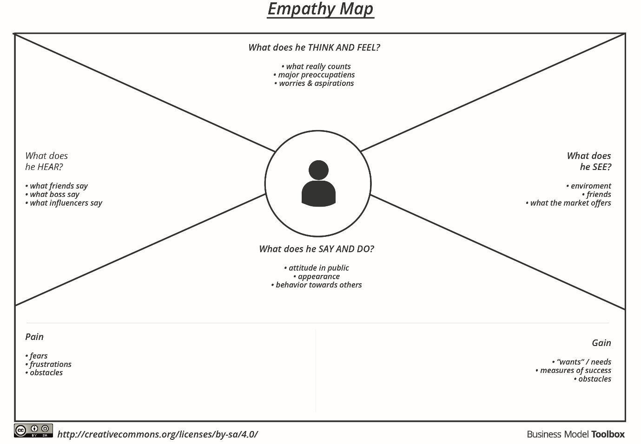
Example:
Worried that a request may be delayed or missed; hopes the issue is fixed quickly.
Teachers and students report Wi-Fi, projector, password and slow-computer problems.
Incident form with a Short Description field; confirmation email after submission.
Creates an IT support ticket with a Short Description, e.g. “WiFi not working in library”.
- Manual review makes classification slow and inconsistent
- No confirmation that the request was received
- Category and Subcategory set automatically at creation
- Reduced manual effort for IT agents
- Confirmation email sent to the caller

Reference: https://www.mural.co/templates/empathy-map-canvas

Example: Auto Ticket Classification using Flow Designer
Example: Food Ordering & Delivery Application
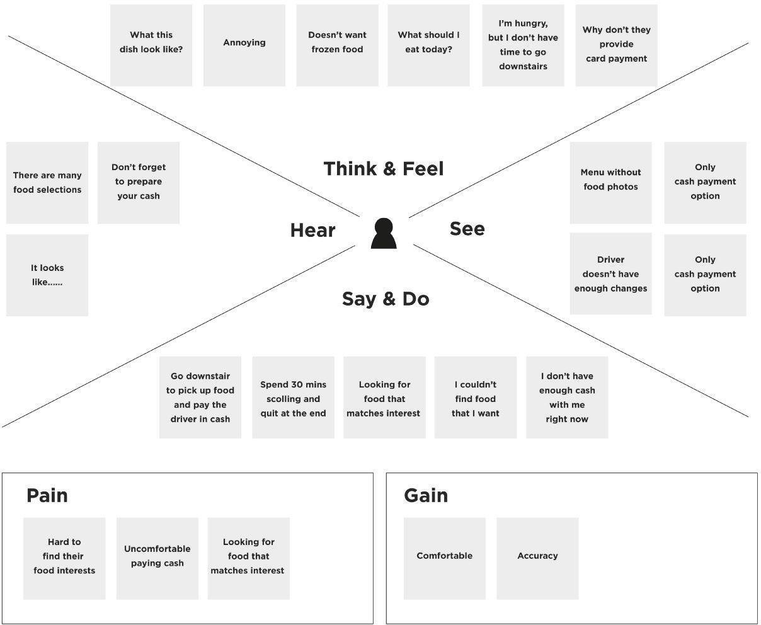

Email confirmation

Auto-classified at creation

No quick confirmation

Inconsistent categories

Manual categorizing is slow

Wait for the IT team

“Projector not turning on”

“WiFi not working in library”

Type a Short Description

Create an IT ticket in Incident Workflow

Category and Subcategory set on ticket

Confirmation email in my inbox

I forgot my password

Tickets wait for a category

IT staff review tickets by hand

Projector failed again

Wi-Fi is down in the library

Did my ticket get submitted?

I need Wi-Fi or projector working now

What should I write in the Short Desc?

I hope it goes to the right team

Frustrated by delays

Will my request be seen?

